Alaska Indoor Gardening Curriculum

Transplanting
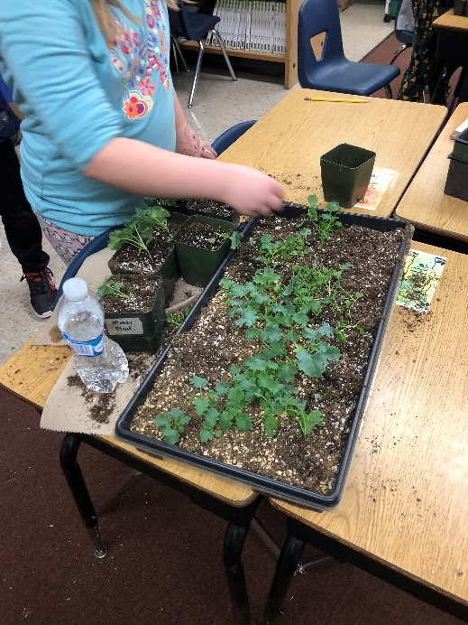
Author/Source: Melissa Sikes, AK AITC

Suggested Grade Levels: All

Time: 45 minutes for one session.

Teaching Goal:
To understand how plants grow and understand how needs change in regards to space required for optimum growth.

Learning Objectives: Students learn how to properly handle and transplant seedlings from one container to another.

Core Ideas:
- Reading and Comprehending Scientific Technical Information
- Horticulture
- Transplanting
- Hydroponics
- Plant Life Cycles
- Array Mathematics and Grids
- Plant light and soil nutrient needs
- Standardized Science Measurements
- Science Journaling
- Recording Scientific Data in Tables
- Drawing Conclusions from Experimentation

Alaska State Science Standards: K-LS1-1, K-2-ETS1-2, 1-LS1-1, 2-LS2-1, 3-LS4-4, 4-LS1-1, 5-LS1-1, 5-LS2-1, MS-LS1-5, MS-ETS1-1, HS-LS1-2

NGSS Standards: K-LS1-1, K-ESS2-2, K-ESS3-1, 1-LS1-1, 2-LS2-1, 3-LS1-1, 3-LS3-2, 4-LS1-1, 5-PS3-1, 5-LS1-1, MS-LS1-5, MS-ETS1-1, HS-LS2-2, HS-ESS2-6,

Materials Needed:
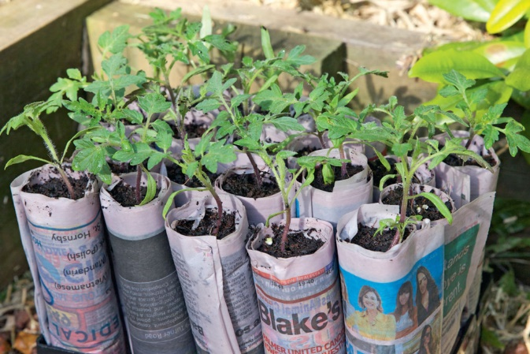
- Garden Soil – preferably a seedling mixture with perlite and peat and minimal bark chunks.
- Seedlings that have been started and have reached a transplantable height and health.
- Plant Labels – popsicle sticks or other kind of plant tags
- Planting containers
- Pencils
- Newspapers
- Scissors
- Tomato Paste or Soup Cans
- Masking Tape
- Spray Bottles

Vocabulary:
- Annuals - Plants that perform their entire life cycle from seed to flower to seed within a single growing season. All roots, stems and leaves of the plant die annually.

- Biennials - Plants which require two years to complete their life cycle. First season growth results in a small rosette of leaves near the soil surface. During the second season's growth stem elongation, flowering and seed formation occur followed by the entire plant's death.

- Germination: Germination is the process by which the seeds begin to grow into the plant.

- Hardening Off - Getting a plant used to being outside in bright light, colder weather, and wind by placing the plants outside for a little bit each day, starting in a shady spot.

- Perennials - Plants that persist for many growing seasons. Generally, the top portion of the plant dies back each Winter and regrows the following Spring from the same root system.

- Transplanting - To move a plant from one planting container to a bigger container, or from a plant container into a garden. It can also mean to move a plant from one place in the garden to another.
Background for Teachers:
Many people start plants by adding more than one seed per plant pot or cell. Once the seeds have sprouted, too many plants growing in one space is not the optimal condition for healthy plants. For some, this is a difficult thing to do, but it must be done. Plants grown under crowded conditions must compete for these essentials and will be less productive. Gardeners thin to give their plants the best possible growing conditions and so must you. For the majority of plants, it is best to thin to one plant per container. This ensures that each plant will have ample space, light, food, water, and air circulation.

Seedlings also may need to be transplanted into larger containers as they grow. Transplanting is an important part of gardening that gives plants the space they need to grow. Moving a seedling to a new place or container is called transplanting. It can be giving a plant a larger container, or moving it to a hydroponic system, or to a garden space outside.

Typically starting in small spaces, like in a six pack container, is fine for the first few inches of plant growth. Different species and varieties have different space and nutrient requirements. When you decide your plants need to be moved into a larger pot, root disturbance should be minimized. Plants should be handled very carefully as you move them to the new container. In all cases, avoiding transplant shock—the stress or damage received in the process—is the principal concern. Make sure the roots have lots of airy soil surrounding them and don’t pack soil after transplanting by pushing down on it. This will break the roots and cause transplant shock. Continuing the watering regimen and not changing the lights is also key to reducing transplant shock.

Different species and varieties react differently to transplanting; for some, it is not recommended. In all cases, avoiding transplant shock—the stress or damage received in the process—is the principal concern. Plants raised in protected conditions usually need a period of acclimatization, known as hardening off. Because plants being moved outside can be shocked and die due to temperature and wind and fluctuations in light intensity due to location you put the plant in, before moving seedlings outdoors it is important harden them off. This means setting them outside for short periods and increasing the time every day but bringing them in to the conditions they were used to when they sprouted in between. Plants can get sunburned and windburned if you don’t harden them off and this will sometimes be too much for them to recover from and grow properly. You won’t notice it right away, but after a day or two, the leaves get whitish splotches on them.

Procedure:
Introduction: Moving plants from one container to another is called ‘transplanting'. Seedlings should be showing their second set of leaves, or true leaves, to be ready to be moved to a new home. Your seedlings should now have grown enough to be ready to be moved to their new home. You need to plant them somewhere with more space as they will not be able to grow as big as they need to if we keep them in the seed trays. You transplant them by very carefully removing them from the seed tray and planting them into another container.

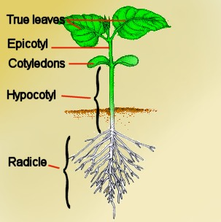
- Ask “Can you find a seedling that has just started to sprout a true leaf?” Most seedlings should have 3-4 true leaves before being transplanted. Show them the picture of a seedling with true leaves. “Can you find any that are ready?”

- If there are too many seedlings in one pot or cell of a six pack, they must thin first before transplanting.

- Explain Thinning. There are several ways to thin. One way is to pinch or cut off the plants at the soil line just pinch or snip off the excess seedlings with small scissors or fingers. The advantage of this method is that it will not damage the roots of the plant left behind. Another way is to pull up the plant, with its root system attached, and transplant it to another location, perhaps into a cell where no seeds germinated. When the seedlings have developed their second set of true leaves, it's time to transplant them.

- Fill a new container with moist planting mix.

- Loosen the soil around the seedlings (a popsicle stick or plastic fork handy for this); then carefully lift them out, one at a time. Never pull out the plant by the stem, scoop the roots. Handle seedlings gently by the roots to avoid damaging the tender stems or leaves. If there is a clump of seedlings, gently lift out the root ball and separate individual plants by carefully teasing apart the tangled mass of roots. Slow and careful teasing will insure root health.

- Poke a hole in the new container's planting mix as deep and wide as the roots on the seedling, place the seedling in the hole, and firm soil around it.

- Water the transplant right away. Place back in the location they were growing in before transplanting to ensure they are not shocked by too many changes.

- Discuss continued care with the students. About 10 days before the seedlings are ready to plant outside, harden them off so they can withstand bright sun and cooler temperatures. Stop fertilizing them and set them outdoors for several hours each day in a wind-sheltered spot that receives filtered light. Over the next week or so, gradually increase exposure until the plants are in full sun all day. Then set them out in the garden or planter boxes.

Transplanting Options:
- Transplant seedlings into larger plastic pots or other containers
- Make paper pots for transplanting later on.
- Put straight into your garden if you have one.
Paper Pots:
- Grab two pages of newspaper (so you have a four-sheet stack). Cut them into thirds lengthwise.

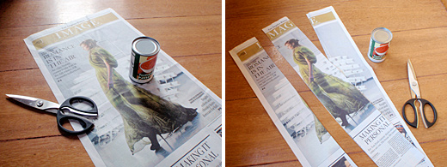
- Place the can on the newspaper and leave about an inch hanging off the end. Roll the can along the newspaper until it’s loosely wrapped all the way around. (Loose being key for easy removal of the can later.)

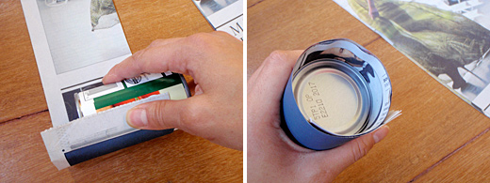

- Fold the edge of the newspaper down over the can and work your way around until all the edges are folded over firmly. They don’t have to be perfect; you can just smash the paper down with your fingers. It’s also fine if there is a small hole where the folds meet in the middle — that just provides extra drainage.

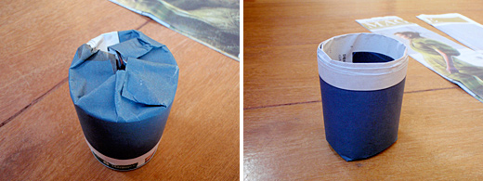
- Flip the can right side up. Press the can down on the folds to really crease the edges against the bottom of the can.
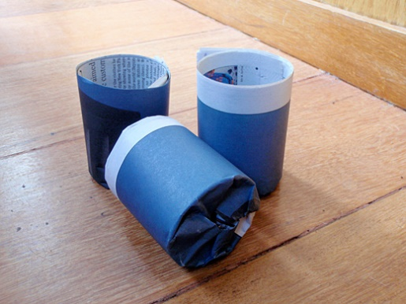

- Slide the can out. Don’t worry if it seems like the pot is flimsy or unraveling, especially at the bottom. You can add a small piece of masking tape if you wish. Once filled with seed starting mix and moistened, the pot is surprisingly sturdy and holds it shape well.
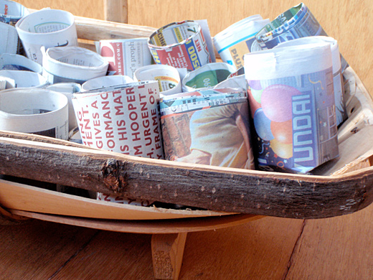

Worksheets: Plant Growth Monitoring Chart

Extensions:
- Indoor Lighting Systems Handout (for setting up your system)
- Seed Science Lesson
- Do You Know the Parts of Plants? Lesson
- Individual Plant Parts Lessons
- Reading the Seed Packet Lesson

Cross Curricular Ideas:
- Ask students to estimate how many seeds they planted in total based on multiplication arrays. How many of those seeds were transplanted today?
- Discuss germination and plant success rates.
- Use standardized measuring tools like tablespoons, measuring cups, pint containers, etc. to scoop soil and water and talk about this.
- Explicitly teach the vocabulary including the prefixes, suffixes, and roots of the gardening words
- Read aloud one of the books (ideas below) and use in a reading center
- Expand the journaling prompts into a writing assignment
- Discuss the plants that grow in their local area and the limitations that outdoor gardeners may face. Ask students what local gardeners may be looking for as they plant shop.
- Have them draw or photograph the plants before transplanting, after transplanting, and two weeks later to show changes in growth. This can be oriented as an artistic opportunity or more of a writing opportunity. But there’s a lot that can be done!

Assessment Options:
- Strong, vigorous plants will be a good measure of success.
- Write a paragraph(s) explaining the process someone should use when transplanting plants.
- Give students requirements and limitations in a different environment and ask them to choose seedlings that may meet the requirement and explain why they chose those plants.
- Ask students to make predictions about what will happen next. The predictions should be based on information from the seedling they selected.
- Evaluate their journal entry. Journal entries vary by grade level and class expectations. But you could consider having the students write a sequence of events, self-evaluation, and sketch of their finished container.
- You could develop a checklist and check off when students or student groups successfully complete parts of the lessons. For example; choosing an appropriate plant, moistening the soil, journaling, behaving appropriately, clean-up, etc.

References:
Books:
From Seed to Plant by Gail Gibbons
ISBN: 0-8234-1025-0 1991

Gardening Indoors with Soil and Hydroponics by George Van Patten
ISBN: 978-1-878823-32-8

Websites:
KidsKonnect – General Gardening information
https://kidskonnect.com/science/gardens/

Johnny’s Selected Seeds Growing Center Information
http://www.johnnyseeds.com/growers-library/growing-center.html

Kids Gardening
https://kidsgardening.org/

Renee’s Garden Resources
https://www.reneesgarden.com/blogs/gardening-resources

Good information on using recycled produce or deli containers for seed starting:
http://reneesgardenseeds.blogspot.com/2014/03/easy-seed-starting-using-recycled.html

